[NAME OF OBJECTOR]

**RELEVANT REPRESENTATION ON THE PROPOSED MORGAN AND MORECAMBE OFFSHORE WIND FARMS TRANSMISSION ASSETS DCO**

**PLANNING INSPECTORATE REFERENCE NUMBER: EN020032**

**INTRODUCTION**

This is a Relevant Representation (**RR**) regarding the Morgan and Morecambe Offshore Windfarm Transmission Assets Project (the **Project**), promoted by Morgan Offshore Wind Limited and Morecambe Offshore Windfarm Limited (the **Applicant**) made by [**OBJECTOR**] (the **[OBJECTOR / SUITABLE ABBREVIATION FOR OBJECTOR]**).

The [**OBJECTOR**] objects to the Project on the grounds set forth in this RR. These grounds raise questions about the Applicant's reasoning for the proposed site locations for the Morgan and Morecambe onshore transmission assets, as well as the detrimental environmental consequences of this decision.

**GROUNDS OF OBJECTION**

1. Site / Route Selection and Alternatives
   1. The Applicant, in selecting the location for its onshore transmission assets, has given preference to development in designated Green Belt land, in contravention of the requirements and guidelines prescribed in [The National Planning Policy Framework](https://assets.publishing.service.gov.uk/media/675abd214cbda57cacd3476e/NPPF-December-2024.pdf) (**NPPF**), the National Policy Statements (**NPS**) [NPS EN-1 (Overarching National Policy Statement for Energy)](https://assets.publishing.service.gov.uk/media/65bbfbdc709fe1000f637052/overarching-nps-for-energy-en1.pdf), [NPS EN-3 (Renewable Energy Infrastructure)](https://assets.publishing.service.gov.uk/media/65a7889996a5ec000d731aba/nps-renewable-energy-infrastructure-en3.pdf), and the [Fylde Local Development Plan](https://new.fylde.gov.uk/wp-content/uploads/2021/12/Fylde-Local-Plan-to-2032-incorporating-Partial-Review-adopted.pdf) (**FLDP**). In particular, safeguarding the environment, responding to local character, reflecting the identity of local surroundings, reducing flood risk, protecting and enhancing local landscapes and, importantly, Green Belt land.
   2. A significant portion of the proposed route for the underground cabling and the Morgan and Morecambe substations is located within the Green Belt between Freckleton and Kirkham. At paragraph 160, the NPPF provides that ‘*when located in the Green Belt, elements of many renewable energy projects will comprise inappropriate development’*, and that where this is the case, ‘*the developers will need to demonstrate very special circumstances if projects are to proceed*’. Paragraph 5.11.20 of NPS EN-1, paragraphs 2.8.57 – 2.8.58 of NPS EN-3, and paragraphs 7.7 -7.8 of the FLDP underline the strict requirement for very special circumstances for using Green Belt land. The Applicant has failed to clearly demonstrate how the Project’s location of onshore transmission assets in Green Belt land qualifies as ‘very special circumstances’, particularly as it has failed to provided evidence of consideration of brownfield sites or alternatives. If a diligent consideration exercise had been conducted, the Applicant would have considered the use of already provided industrial development land and electricity transmission infrastructure, as outlined in paragraphs 1.14 to 1.21 of this RR.
   3. Paragraph 2.2.10 of the [NPS EN-5 (Electricity Networks Infrastructure)](https://assets.publishing.service.gov.uk/media/65a78a5496a5ec000d731abb/nps-electricity-networks-infrastructure-en5.pdf), with reference to section 9 and Schedule 9 of the Electricity Act 1989 (as amended), requires that the Applicant has “*regard to the desirability of preserving natural beauty, of conserving flora, fauna and geological or physiographical features of special interest and of protecting sites, buildings and objects of architectural, historic or archaeological interest; and… do what [they] reasonably can to mitigate any effect which the proposals would have on the natural beauty of the countryside or on any such flora, fauna, features, sites, buildings or objects*.” The Applicant appears to have disregarded most if not all of these considerations.
   4. In terms of size, the dimensions of the substations are disproportionately large and intrusive, and the reason for this remains unclear. The Applicant proposes to take 22.35 hectares of Green Belt land for a system with a headline output of 2GW. By contrast, the two converter substations for the 2.4GW Dogger Bank A&B Offshore wind farms occupy a footprint of a total of 7.5 hectares. Additionally, the substations for the Hornsea One and Two wind farms, which generate 2.5GW, have a footprint of 7.1 hectares, and the substation for the Mooir Vannin wind farm (see paragraph 1.6 below), which is expected to generate 1.4GW, has a maximum footprint of 6.6 hectares. Considering this, the 16.6 hectare footprint for the Morgan substation and 5.95 hectare footprint for the Morecambe substation appear to be extremely large when their combined output is 2GW. Insufficient explanation or justification has been provided by the Applicant. Had the Applicant chosen a smaller design, this would have increased their pool of possible locations, potentially eliminating the need to take Green Belt land.
   5. The [**OBJECTOR**] acknowledges and welcomes the Applicant’s efforts to reduce and streamline certain aspects of its Project design since its consultation on the Preliminary Environmental Information Report (**PEIR**). Nevertheless, certain crucial aspects are yet to be addressed or justified. For example, the maximum height of the Morecambe substation has decreased from 20 meters to 13 meters, but the equivalent metric for the Morgan substation has decreased from 20m to only 15m. There is no explanation provided for this distinction. These heights exclude the significantly taller lightning protection masts that will be positioned across both substation locations. These heights are higher than any building within the Green Belt or any of the surrounding residential centres. In addition, the temporary access track width for both substations has been increased from 15 meters to 20 meters.
   6. It is unclear why both substations could not be combined into a single site, where reasonable separation measures would ensure the independence of the Morgan and Morecambe lines. The placement of these substations in close proximity has the effect of doubling the environmental impacts. In addition, the choice of an 8 kilometre search zone for the placement of the substations is not explained, and the chosen site is situated at the very edge of this zone as shown in **Figure 1** and **Figure 2**. The [Mooir Vannin Offshore Windfarm Project](https://orsted.im/mooirvannin/document-library), a [NSIP connecting from the Isle of Man to the Penwortham substation](https://assets.publishing.service.gov.uk/media/671125ef386bf0964853d766/east-irish-sea-transmission-project-section-35-direction.pdf) has not only demonstrated a search area (covering north to Fleetwood), but has also included the Hillhouse route (detailed in paragraphs 1.14 to 1.21 below) within its scope. If substations can be separated from the Penwortham substation, why couldn't they be further away? If distance has a greater impact due to a higher voltage cable between the substation and Penwortham, why was this not factored in to give greater weight to closer options rather than choosing a site at the limit of the chosen search area.

**Figure 1**

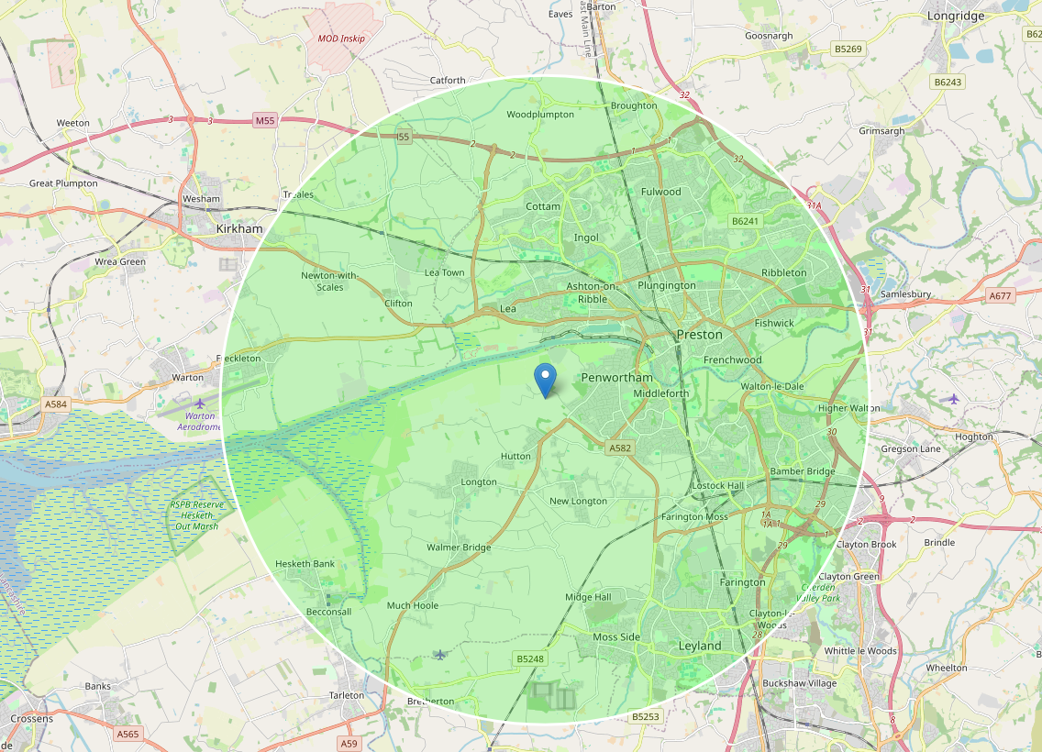

**Figure 2**

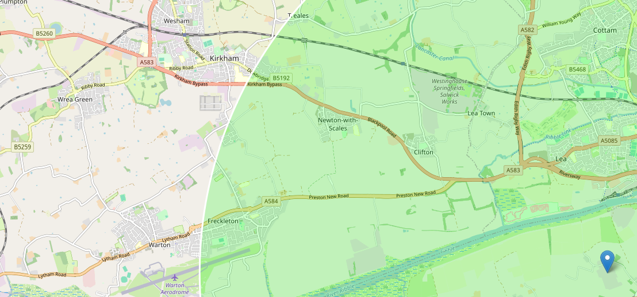

* 1. In terms of timing, the [**OBJECTOR**] understands that the Morgan and Morecambe limbs of the Project may run to different timelines, which not only significantly prolongs the completion timeframe, but also effectively doubles the disruption and environmental impacts resulting from the construction phase of the Project.
  2. The acquisition of farmland required for the construction of the two substations and the cable corridors will result in the permanent loss of agricultural land across Fylde, which is crucial for the viability of local farming activities, whether they be arable, dairy, or sheep farming. It is expected that over 45 farms along the cabling route will be adversely impacted by the Project. The land supports not only crop production but also livestock grazing, which are integral to the livelihoods of the farming community. Acquisition of farmland will not only disrupt business continuity and create long term adverse socio-economic harm to these vital businesses, but it will reduce the total land available for farming in the region and create economic hardship for farmers who may find it challenging to find suitable replacement land even if financially compensated.
  3. In the short and medium-term, the construction of the substations and the additional works required to access and lay down the cables will result in significant land loss to dairy and livestock farms. This is due to the impacts of noise, disruption to the herds, impediments to access to pastures. As highlighted in paragraph 1.7 above, the two substations and cabling corridors are distinct and pertain to distinct projects, the sequencing and timing of the works may result in a construction timeline that extends beyond 6 years (up to 12 years). This uncertainty has a profound negative impact on the operational viability of the farms and the level of investment they receive from landowners and tenants.
  4. The [**OBJECTOR**] understands that the Applicant is undertaking existing land drainage assessments, with a view to connect the Project into the surrounding land drainage systems. However, the surrounding land drainage systems have historically been designed to carry rainwater from permeable topsoil and subsoil, not from large hard standing substation pads. There are no apparent substation site designs that include internal storm tanks to collect and hold surface and roof water runoff in times of storm. Therefore, any internal or perimeter land drainage works that are proposed will not be able to cope with storm events.
  5. In the long-term, the buried cables will continue to pose challenges because the land is soft, mossy, and marshy. It is a well-documented and recognised risk that cables installations in such land will rise over time, which will compromise field operations. As the cables will be left in perpetuity, they will present a long-term hazard and liability to farming in the future with no planned mitigation strategy or provision from the Applicant. On a holistic level, the permanent loss of land challenges the long-term viability of these dairy farms due to restrictions in pasture availability relative to the size of the herds. As farm businesses operate in highly competitive markets, characterised by tight profit margins, the construction and operation of the two substations and cabling routes presents very real challenges in disrupting operations, and ultimately, threatening the existence of these businesses.
  6. On a related vein, there will also be significant impacts on small local businesses and enterprises. For example, we are concerned that the Wrea Green Equestrian Centre Riding School aimed at creating a recreational space for the disabled community will likely close due to the adverse negative impacts on the horses caused by the construction and operation of the substations and cable corridors. Elevated stress levels in horses as a result of noise and vibration impacts could present safety risks for the riders. Closure of the equestrian centre would have a detrimental social and economic impact on the local community, particularly the disabled, who depend on it for recreation, education, and therapy.
  7. The [**OBJECTOR**] is concerned that approval of the Applicant’s Project as proposed would have the effect of downgrading the weight of consideration to be afforded to Green Belt land, resulting in urban sprawl and a gradual loss of green belt protections which contravenes with the NPPF and multiple NPS as highlighted above. Furthermore, it would disregard a number of strategic and non-strategic development policies in the FLDP concerning the use of Green Belt land, protection of existing open spaces, Fylde’s economy, tourism, leisure and community facilities. The [**OBJECTOR**] would iterate that violations of the FLDP, as the primary framework document that establishes the vision and direction for development within its boundaries as approved by the Secretary of State, should not be taken lightly. As an alternative, the [**OBJECTOR**] strongly advocates for and advises the Applicant to withdraw the application and promote the Hillhouse alternative set out below instead.

*Alternative – Hillhouse Technology Local Enterprise Zone*

* 1. The Local Development Frameworks across the Fylde Coastal Plain have provisioned 3 Local Enterprise Zones (**LEZ**) with infrastructure, utilities connectivity and planning support to facilitate development such as the Project being proposed by the Applicant. These also offer close and even adjacent access, re-use and upgrade of existing electricity transmission infrastructure which provides connectivity to the Penwortham substation, without additional further major planning, given its status and existing easement portfolio. These LEZs are segregated from countryside and residences, whilst being designed for multi-activity commercial use.
  2. There is no evidence submitted by the Applicant to suggest that the Hillhouse Technology LEZ (**HTEZ**) has been considered as a component of the land route to Penwortham, which would be via the Stanah substation. This 138-hectare site has been specifically allocated to support development in the energy sector, so could accommodate the 22.35 hectares of the proposed designs of the 1.5GW Morgan and the 0.5GW Morecambe converter substations, their respective construction compounds, road networks, utilities infrastructure, etc. It currently houses infrastructure for the Walney2 Offshore wind farm and has a direct connection with the National Grid Stanah substation with space for any increased capacity requirements.
  3. An informal examination of the Stanah substation has revealed that the existing overhead power lines and substation would need to be upgraded. However, the Stanah substation is connected to the main North-Southwest branch of the Grid that runs between Heysham and Penwortham, with the T junction being at Hambleton, whilst the east branch runs beside the M6 and then around Preston to the West before also feeding into Penwortham.
  4. Furthermore, the [**OBJECTOR**] would point to the fact that National Grid have notified residents and landowners around Stanah, North Fylde and Hambleton of their intent to upgrade the Stanah substation and Tee to permit carriage of increased power levels, matching the grid loop from Heysham to Penwortham.
  5. This option offers a shorter land route whose connection could be upgraded comparatively easily, if the existing overhead pylons are re-strung to increase power carrying capacity with an increased number of conductors attached, potentially with reinforcement of the pylons. All easements for access to the existing overhead lines already exist, and an upgrade would not require major planning activity. The owners of the Hillhouse site are pursuing the development of a Green Hydrogen facility at Stanah, using the underground Halite Caves on the East Side of the Wyre for storage.
  6. The HTEZ route would also be in alignment with NPS EN-5, with reference to section 9 of the Electricity Act 1989 (as amended), as the Applicant has a duty to develop and maintain and develop and efficient, coordinated and economical system of electricity distribution. To use existing infrastructure as part of this would undoubtedly mean streamlined costs, enabling the consumer to receive electricity at the lowest cost. There is evidence available that the proposal to utilise Stanah would achieve a substantial net cost saving overall of some £400 Million, based on 2012 published data, compared to the current proposed underground connection across South Fylde
  7. The [**OBJECTOR**] recommends that the applicant investigate and carry out a detailed assessment of the possibility of this alternative route and location of substation, especially whether power from either or both of the Morgan and Morecambe developments or Mooir Vannin proposed developments can be supported by the Stanah HTEZ route, based on a normal generation of 40% capacity. Any surplus power could be used on site to support the hydrogen production facility. **Figure 3** illustrates the more simplified route when considering the Stanah Grid substation connection.

**Figure 3**

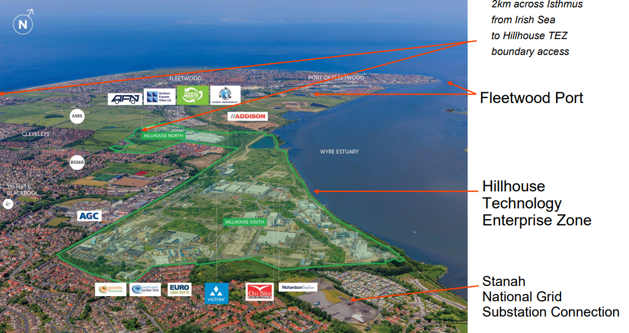

* 1. In summary, should the Morgan and Morecambe windfarms opt to connect to the Hillhouse site, this would bring about the following benefits:
     1. A route that only requires drilling underground for 4 kilometres.
     2. Although it will require upgrading the lines and pylons from Stanah to the Grid, this should be much cheaper than the proposed 30 kilometre corridor.
     3. Hillhouse is a brownfield site and is outside the Green Belt and is therefore a much more preferable alternative to avoid the Green Belt and maintain separation between rural communities.
     4. Springfields (Westinghouse) are seeking to develop large-scale hydrogen production at Hillhouse, which would be a good use of the spare capacity in the local area for local benefit. The current corridor only exports to the National Grid, with no local benefit.
     5. The Fleetwood MP and Town council see this as an opportunity for growth in HTEZ.
     6. Investment in this area will also attract extra skilled jobs into Fleetwood Town Council (one of the [most deprived areas in Lancashire](https://www.lancashire.gov.uk/media/912497/wyre_e07000128_imd2019.png)) and into the port for the offshore work that would be needed to support the windfarms.

1. Cumulative Impacts
   1. The Newton with Clifton Parish comprises of rural countryside with two main settlements:
      1. Newton with Scales being approximately 125 acres; and
      2. Clifton being approximately 60 acres.
   2. At present, the Springfields nuclear fuel energy site, in conjunction with numerous solar energy projects located to the north of Clifton, at Clifton Marsh, and at Halls Cross, already entails the allocation of a total of 225 acres for green energy in Newton and Clifton Parish, with an additional 42 acres situated in close proximity.
   3. The Project, if consented as proposed, would add two additional substations in addition to the existing 170-acre solar farm application at Clifton Marsh, south of the A584, and a 79-acre solar farm application to the west of Parrox Lane which are also in the process of being considered by Fylde Borough Council.
   4. This is a high concentration of energy generation projects within a limited radius, which would significantly alter the long-standing character of the rural settings in a short period of time, which should further count against the project as a cumulative impact. Given that PINS has recognised Mooir Vanin as a NSIP, this brings into question whether an energy super highway is being built in order to satisfy future input into the National Grid.
2. Deficient Community Engagement and Consultation
   1. The consultation outcome may have been at risk of having been predetermined. For example, there was a consultation on the proposed landfall site at Blackpool Airport, but this was already decided by the Holistic Network Design carried out by National Grid in 2022. Similarly, the decision to make Penwortham substation the end point did not occur as a result of consultation or engagement as no such dialogue took place with stakeholders or communities impacted by the Project. All other potentially viable route options have been disregarded in favour of the proposed 30-kilometre corridor.
   2. The consultation on the PEIR did not comply with the legal definition of 'preliminary environmental information' at regulation 12(2) of the Infrastructure Planning (Environmental Impact Assessment) Regulations 2017, in that information that the applicant possessed was not included. For example, landowners were shown more precise details of the substations on maps prior to the statutory consultation process and events, and those detailed maps were not provided in the PEIR.
   3. Furthermore, at consultation events, no-one present was sufficiently qualified to answer questions from attendees, and thus the events were merely presentation of proposals rather than any attempt at engagement, the purpose of pre-application consultation. The consultation events were held too late in the process to allow the consultees to prepare their responses. The decision to open the consultation on October 12 and only hold the first event on October 26 suggests a strategy designed to obstruct any meaningful consultation.
   4. Indeed, both [Fylde Borough Council](https://infrastructure.planninginspectorate.gov.uk/wp-content/ipc/uploads/projects/EN020032/EN020032-000650-Fylde%20Borough%20Council.pdf) and [Lancashire County Council](https://infrastructure.planninginspectorate.gov.uk/wp-content/ipc/uploads/projects/EN020032/EN020032-000649-Lancashire%20County%20Council.pdf) refused to issue an Adequacy of Consultation Notice in autumn 2024. It is understood that the Applicant ‘s failure to clearly set out any community benefits in respect of carrying out the Project and their lack of commitment to address this prior to consultation was one of the reasons for Fylde Borough Council’s refusal to grant an Adequacy of Consultation Notice. In the [**OBJECTOR’S**] view, the Applicant is unable to clearly list any direct community benefits because these are few, if any, which are outweighed by the disadvantages as highlighted throughout this RR.
3. Ecology
   1. The sand dunes at Lytham St Annes are home to the Sefton Sand Lizards (*Lacerta agilis*), one of the rarest lizard families in the UK. These reptiles are strictly protected under Schedule 5 of the Wildlife & Countryside Act 1981 (as amended) and under Schedule 2 of the Conservation (Natural Habitats &.) Regulations 1994 (as amended). Following a decline in numbers during the 1960s, attributed to the loss of habitat, among other factors, the recent decade has witnessed significant conservation efforts, leading to an increase in populations that could potentially be jeopardized if not carefully considered.
   2. The Project proposes to permanently remove four ponds as part of constructing the substations. Given that the Fylde is very flat and wet, it provides an ideal habitat for Great Crested Newts, which would be directly impacted by these works. This presents a significant risk, given the recent discovery of Great Crested Newt populations in an adjacent field.
   3. A few metres away from the location of the proposed substations, there exists a significant population of critically endangered Black Tailed Godwits on the Newton Marsh SSSI. Similarly, it has been recorded that Black Tailed Godwits were nesting on Freckleton Marsh which lies adjacent to the fields. Both Great Crested Newts and Black-Tailed Godwits should be recognized in the DCO for special protection.
   4. The cable corridors for the Project traverse through the biological heritage site of Lytham Moss, which comprises 283 hectares of farmland on the Lytham Moss between Heyhouses, Long Wood and Peel. The site is of ornithological importance as a winter feeding ground for pink footed geese and whooper swans.
   5. Furthermore, a range of [protected species](https://www.gov.uk/government/publications/habitats-and-species-of-principal-importance-in-england) can be found near the area of the substations. These include:
      1. Bats (pipistrelle)
      2. Toads
      3. Ring Ouzel
      4. Thrush
      5. Dunnock
      6. Starlings
      7. Sparrows
      8. Brown Hares
      9. Hedgehogs
   6. Protected Species Licences from Natural England or Defra have not been obtained to allow activities that would otherwise be illegal, and these or letters of no impediment should be obtained before the Project is consented. Protected species licensing requirements are in addition to the requirements for planning permission and we have not seen evidence of this.
4. Burial Grounds at Quakers Wood
   1. The location of the Morecambe substation (and associated mitigation and access rights), as shown on the [Work Plans](https://infrastructure.planninginspectorate.gov.uk/wp-content/ipc/uploads/projects/EN020032/EN020032-000621-B7_Part%202%20of%202_MMTA_Works%20Plans%20-%20Onshore%20and%20Offshore.pdf) as works 20b, 22b, 23b, and 24b, appear to overlap with Quakers Wood. Following archaeological research conducted by Oxford University, it has come to our attention that Quakers Wood as depicted in **Figure 4** (and marked as 49 and 52) was utilised as burial grounds by Quaker communities, and generally as burial grounds by surrounding communities (see markings 76 and 126).
   2. It is estimated that between 50-60 burials occurred without headstones. Furthermore, it is anticipated that other surrounding fields have the potential to hold significant archaeological features and/or artefacts, which must be considered before any on-site works take place. On this basis, we object to any invasive works being carried out on these grounds subject to deploying an archaeological survey. Any issues brought to light therein should be adequately and sensitively addressed. Furthermore, there is no provision in the DCO to deal with human remains.

**Figure 4**

1. Landscape and Visual Impact
   1. The visual impact of the substations and cable corridors running though the countryside is very significant, and any screening will itself have a visual impact. For example, paragraph 10.12.5 onwards of [Chapter 10: Landscape and Visual Resources](https://infrastructure.planninginspectorate.gov.uk/wp-content/ipc/uploads/projects/EN020032/EN020032-000522-F3.10_MMTA_ES_Landscape%20and%20visual%20resources.pdf) of the Environmental Statement (**ES**) shows several major and moderate adverse visual impacts from the substations.
   2. **Figure 5** shows a view of the substations from a public footpath. However, no renderings of the substations show the impact on the settings of the heritage assets.

**Figure 5**

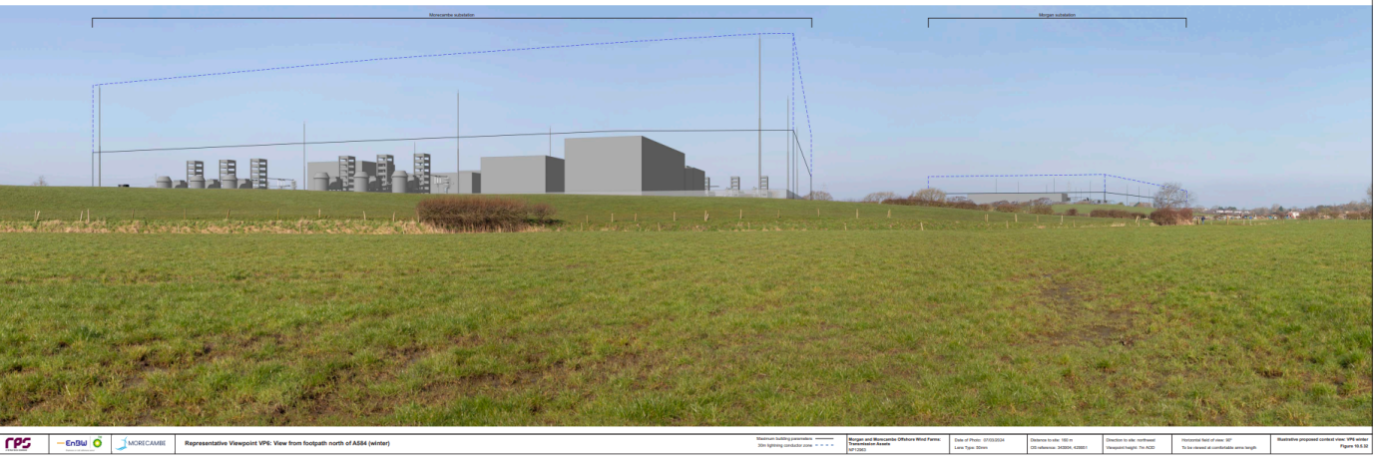

* 1. The cluster comprising of Dagger Cottage (1164155), Dixons Farmhouse (1072035) and The White Barn (which is curtilage listed) is significantly impacted from the views from Grange Lane, Thames Street, Newton with Scales. **Figure 6** provides a layman’s view from the corner of Grange Lane and Thames Street of how the southern substation (represented by the blue box) will have a significant impact on the setting of these heritage assets.

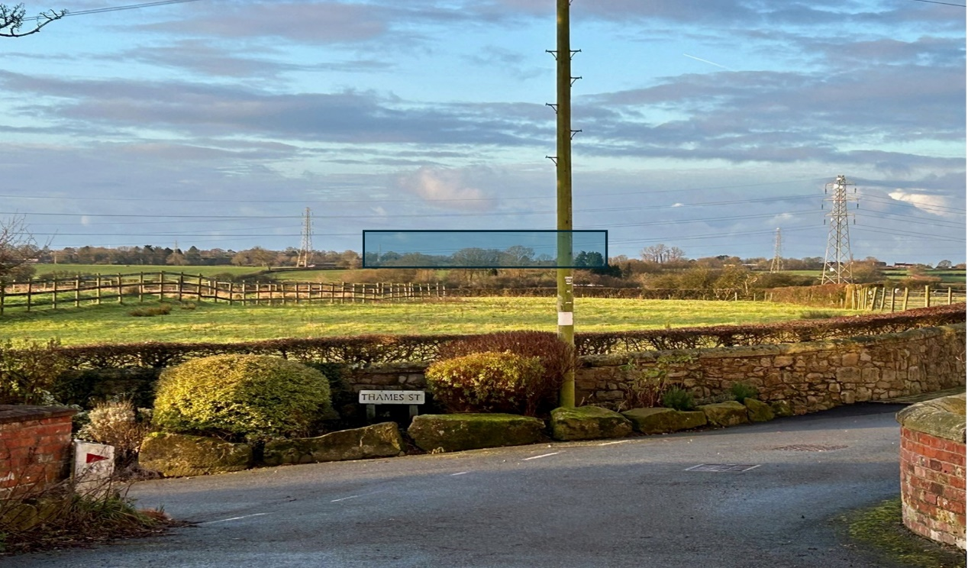**Figure 6**

* 1. Both substations create a visual intrusion on the rural landscape. This has a significant impact as Fylde and as nearby areas like Lytham St Annes rely heavily on tourism, industrial infrastructure would undoubtedly reduce the area’s rural charm. The rural charm of these routes and the establishment of Public Right of Way (**PRoW**), country lanes and tracks to enjoy them are the primary reasons that attract tourists, walkers and riders to make extensive use of these routes as recreational spaces. Construction activity will make these roads significantly more dangerous. Moreover, some PRoWs will be totally closed-off due to construction works. Many of the lanes lack footpaths, and construction traffic will make walking these roads dangerous. All these aspects will have a negative impact on residents' physical and mental wellbeing.

1. Traffic Disruptions
   1. Creation of the substations and cable corridors will require significant construction work, which will disrupt local roads through the creation of noise, dust, and traffic congestion of local communities. These impacts congestion impacts will be detrimental to tourism and local businesses.
   2. Table 7.21 of [Chapter 7: Traffic and Transport](https://infrastructure.planninginspectorate.gov.uk/wp-content/ipc/uploads/projects/EN020032/EN020032-000509-F3.7_MMTA_ES_Traffic%20and%20Transport.pdf) of the ES shows substantial percentage increases in heavy good vehicles on roads and motorways. For example:
      1. 1,400% increase on Leach Lane North / Appealing Lane / The Hamlet
      2. 1,740% increase on Blackpool Road North from Kilnhouse Lane junction and access A5
      3. 345% increase on Ballam Road between Peel Road and accesses A16 / A19
      4. 656% increase on Ballam Road between Peel Road and Fox Lane Ends
   3. The Applicant does not consider mitigation for the impact on users of highways or Public Rights of Way, where the introduction of abnormally shaped construction vehicles will block up the width of certain roads. For example, Lower Lane Freckleton, Bryning Lane and multiple Public Rights of Way.
2. Noise and Vibration
   1. The substations and cable corridors are very close to residential properties and schools including Strike Lane Primary School, Newton Bluecoat Church of England Primary School and Carr Hill High School.
   2. No information has been provided regarding the possible acoustic issues that may surround substation equipment, which may produce a low frequency 50hz background hum (estimated to be about 60dB) which can be significant in the context of the sensitive receptors identified above. What information that is available suggests that a noise level in excess of 35dB above ambient is to be expected. This is intolerable for anyone living close to the development and experience suggests that in some weather conditions the noise footprint would be far wider than predicted.
3. Flooding
   1. Much of Lytham lies below sea level. The [Climate Central Coastal screening tool risk map](https://coastal.climatecentral.org/map/13/-2.8928/53.7424/?theme=sea_level_rise&map_type=year&basemap=roadmap&contiguous=true&elevation_model=best_available&forecast_year=2050&pathway=ssp3rcp70&percentile=p50&refresh=true&return_level=return_level_1&rl_model=coast_rp&slr_model=ipcc_2021_med) shows much of Lytham and St Annes underwater by 2050. Drilling wide cable corridors under the sand dunes, will weaken the current coastal defences. Undermining the sand dunes and constructing a concrete corridor for cables could potentially create a corridor for water to travel inland, resulting in the flooding of vulnerable residential areas much earlier than anticipated.
   2. The Applicant has only recently requested affected farmers to identify whether or not their fields hold water at any time of the year, indicating that they do not understand the topography of the southern Fylde, which still contains large areas of designated marsh adjacent to the areas being considered. Much of the rest of the Fylde, which is particularly low lying as shown by the EA flood maps, is reclaimed marsh and relies on the effectiveness of the drainage systems created over a long period starting with Lytham Moss in the 17th century. This includes the existing main river tributaries, the associated dykes and ditches and extensive use of buried land tiles/drains to drain the area. Damage will naturally worsen the ability to drain the land and ensure more areas retain water, rather than have it drain.
4. Draft Development Consent Order

Comments in respect of the draft Development Consent Order.

Project A - Morgan

* 1. Requirement 3 – Stages of authorised project – For clarity, a provision should be added or (3) modified so that it requires the Applicant to implement the scheme as approved by the relevant planning authority.
  2. Requirement 7 – Implementation and maintenance of landscaping – For clarity, a provision should be added requiring the Applicant to implement the landscaping scheme as approved under Requirement 6.
  3. There is no landfall construction method statement concerning works (Work Nos. 3A, 4A, 5A, 6A, 7A, 8A, 9A, 10A, 36A, 38A, 42A, 43A and 47A together with any other authorised development associated with those works and related ancillary works). A provision governing this process ought to be included to the effect that (1) no landfall construction work may commence until a method statement or equivalent has been submitted and approved by the relevant planning authority, and (2) the method statement referred to above is implemented as approved.
  4. Requirement 8 – Code of construction practice – (3) only concerns Project A onshore works, does this apply to Project A intertidal works? Please justify if not or otherwise amend to include Project A Intertidal works.
  5. Requirement 9 – Traffic and Transport – (3) only concerns Project A onshore works, does this apply to Project A intertidal works? Please justify if not or otherwise amend to include Project A Intertidal works.
  6. Requirement 11 – Onshore archaeology – similar projects have been prescriptive with the detail that ought to be included in the archaeological written scheme of investigation. Please include further detail on what such schemes will cover.
  7. Requirement 13 – European protected species onshore – (3) only concerns Project A onshore works, does this apply to Project A intertidal works? Please justify if not or otherwise amend to include Project A Intertidal works.
  8. Requirement 14 – Construction hours – construction hours on Saturdays are typically 0700 hours to 1300 hours, is there a justification for why the hours are 0700 hours to 1900 hours Monday to Saturday? For (3) a provision ought to be added to the effect that such approved works must be completed within the agreed time. The [outline Code of Construction Practice](https://infrastructure.planninginspectorate.gov.uk/wp-content/ipc/uploads/projects/EN020032/EN020032-000554-J1_MMTA_Outline%20Code%20of%20Construction%20Practice.pdf) at paragraph 1.6.2.1 provides that no core working will be undertaken on Sundays or Bank Holidays, except in exceptional circumstances. There is no inclusion or reference to such exceptional circumstances in Requirement 14. For the avoidance of ambiguity please detail what situations may give rise to such exceptions or if not required remove such wording as this carries the risk of establishing conflicting exceptions.
  9. Requirement 15 – Fencing and other means of enclosure - For clarity, a provision should be added requiring the Applicant to complete the fencing and other means of enclosure works as approved by the relevant planning authority.
  10. Requirement 16 – Restoration of land used temporarily for construction – as drafted, there is no hard timescale for the Applicant to carry out the restorative works which carries the risk of potential slow progress. We suggest that any restorative works are completed within 12 months of completion of the relevant stage of the Project A onshore works and Project A intertidal works, or such other period as the relevant planning authority may approve.
  11. Requirement 18 – Control of noise during operational stage – while this requirement makes reference to the noise management plan, there is no specific sound level (in decibels) expressly stated which must not be breached at any time. This detail ought to be included given its significance.

**Project B - Morecambe**

* 1. Many of the concerns are the same as for Project A but are listed here for completeness.
  2. Requirement 3 – Stages of authorised project – For clarity, a provision should be added or (3) modified so that it requires the Applicant to implement the scheme as approved by the relevant planning authority.
  3. Requirement 7 – Implementation and maintenance of landscaping – For clarity, a provision should be added requiring the Applicant to implement the landscaping scheme as approved under Requirement 6.
  4. There is no landfall construction method statement concerning works (Work Nos. 4B, 5B, 6B, 7B, 8B, 9B, 10B, 36B, 38B, 42B, 43B and 47B together with any other authorised development associated with those works and related ancillary works). A provision governing this process ought to be included to the effect that (1) no landfall construction work may commence until a method statement or equivalent has been submitted and approved by the relevant planning authority, and (2) the method statement referred to above is implemented as approved.
  5. Requirement 8 – Code of construction practice – (3) only concerns Project B onshore works, does this apply to Project B intertidal works? Please justify if not or otherwise amend to include Project B Intertidal works.
  6. Requirement 9 – Traffic and Transport – (3) only concerns Project B onshore works, does this apply to Project B intertidal works? Please justify if not or otherwise amend to include Project B Intertidal works.
  7. Requirement 11 – Onshore archaeology – similar projects have been prescriptive with the detail that ought to be included in the archaeological written scheme of investigation. Please include further detail on what such schemes will cover.
  8. Requirement 13 – European protected species onshore – (3) only concerns Project B onshore works, does this apply to Project B intertidal works? Please justify if not or otherwise amend to include Project B Intertidal works.
  9. Requirement 14 – Construction hours – construction hours on Saturdays are typically 0700 hours to 1300 hours, is there a justification for why the hours are 0700 hours to 1900 hours Monday to Saturday? For (3) a provision ought to be added to the effect that such approved works must be completed within the agreed time. The [outline Code of Construction Practice](https://infrastructure.planninginspectorate.gov.uk/wp-content/ipc/uploads/projects/EN020032/EN020032-000554-J1_MMTA_Outline%20Code%20of%20Construction%20Practice.pdf) at paragraph 1.6.2.1 provides that no core working will be undertaken on Sundays or Bank Holidays, except in exceptional circumstances. There is no inclusion or reference to such exceptional circumstances in Requirement 14. For the avoidance of ambiguity please detail what situations may give rise to such exceptions or if not required remove such wording as this carries the risk of establishing conflicting exceptions.
  10. Requirement 15 – Fencing and other means of enclosure – For clarity, a provision should be added requiring the Applicant to complete the fencing and other means of enclosure works as approved by the relevant planning authority.
  11. Requirement 16 – Restoration of land used temporarily for construction – as drafted, there is no hard timescale for the Applicant to carry out the restorative works which carries the risk of potential slow progress. We suggest that any restorative works are completed within 12 months of completion of the relevant stage of the Project B onshore works and Project B intertidal works, or such other period as the relevant planning authority may approve.
  12. Requirement 18 – Control of noise during operational stage – while this requirement makes reference to the noise management plan, there is no specific sound level (in decibels) expressly stated which must not be breached at any time. This detail ought to be included given its significance.

Conclusion

Given the above concerns, while the substations and existing cable corridors remain in their proposed locations, the [OBJECTOR] opposes to these elements of the Project, and will continue to do so throughout the process until the Application has been withdrawn or their impacts have been reduced to acceptable levels, particularly given that the Applicant has failed to explore the Hillhouse option discussed above which offers a far more logical and suitable option to carry out the Project. In the [OBJECTOR’S] view, the Project, as proposed, simply disregards a number of crucial considerations stipulated in the NPPF, NPS and the FLDP as highlighted in this RR which must be addressed with due consideration as required and intended by the policy documents.